Physical Activity
Exercise is important for everyone. It helps to tone and tighten the body, increase endorphins which help positive mood balance, aids in circulation, and helps with maintaining a healthy weight. Always make sure to check with your physician before starting a workout program and provide supervision for the individual with DS. When starting a workout program, start light and slow until a tolerance and endurance is built up. Cardio provides a positive effect with weight loss. Being as though individuals with DS tend to burn between 2-300 calories less than most individuals, it is important to develop an exercise and food plan that utilizes less food calories and burns more calories.
ALWAYS, check with your doctor before starting with any exercise regimen and it is recommended to get a physical exam. When it comes to exercising, keep it short, interesting, and fun. Make it a goal to achieve 20-30 minutes of exercise, 3-4 times per week.

Ways to get in physical activity
Swimming
Walking/jogging
Stationary bike
Dancing
Take stairs over the elevator
Walk the dog
Raking leaves
Park further than normal when shopping, to ensure walking more steps
Cleaning
Wash the car
Make a small vegetable or flower garden and allot time to work in it

Physical Activity
Exercise is important for everyone. It helps to tone and tighten the body, increase endorphins which help positive mood balance, aids in circulation, and helps with maintaining a healthy weight. Always make sure to check with your physician before starting a workout program and provide supervision for the individual with DS. When starting a workout program, start light and slow until a tolerance and endurance is built up. Cardio provides a positive effect with weight loss. Being as though individuals with DS tend to burn between 2-300 calories less than most individuals, it is important to develop an exercise and food plan that utilizes less food calories and burns more calories.
ALWAYS, check with your doctor before starting with any exercise regimen and it is recommended to get a physical exam. When it comes to exercising, keep it short, interesting, and fun. Make it a goal to achieve 20-30 minutes of exercise, 3-4 times per week.

Ways to get in exercise at home or out
Walking/jogging
Stationary bike
Dancing
Take stairs over the elevator
Walk the dog
Raking leaves
Park further than normal when shopping, to ensure walking more steps
Cleaning
Wash the car
Make a small vegetable or flower garden and allot time to work in it
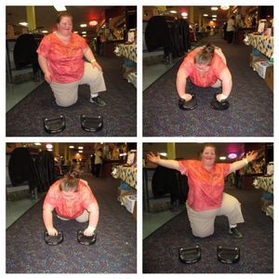
This is a picture of Lauren demonstrating the perfect push-up exercise! :)

